http://mandypc:8399/201504layer/
http://mandypc:8099/arcgismanager/main/main.jsf （ arcgismanager / gisserver ）

统计功能，Sum， 修改css， 二次开发
统计字段功能 （ArcGIS Server开发从入门到精通.pdf）
http://www.baike.com/wiki/ArcGISServer%E5%BC%80%E5%8F%91%E4%BB%8E%E5%85%A5%E9%97%A8%E5%88%B0%E7%B2%BE%E9%80%9A

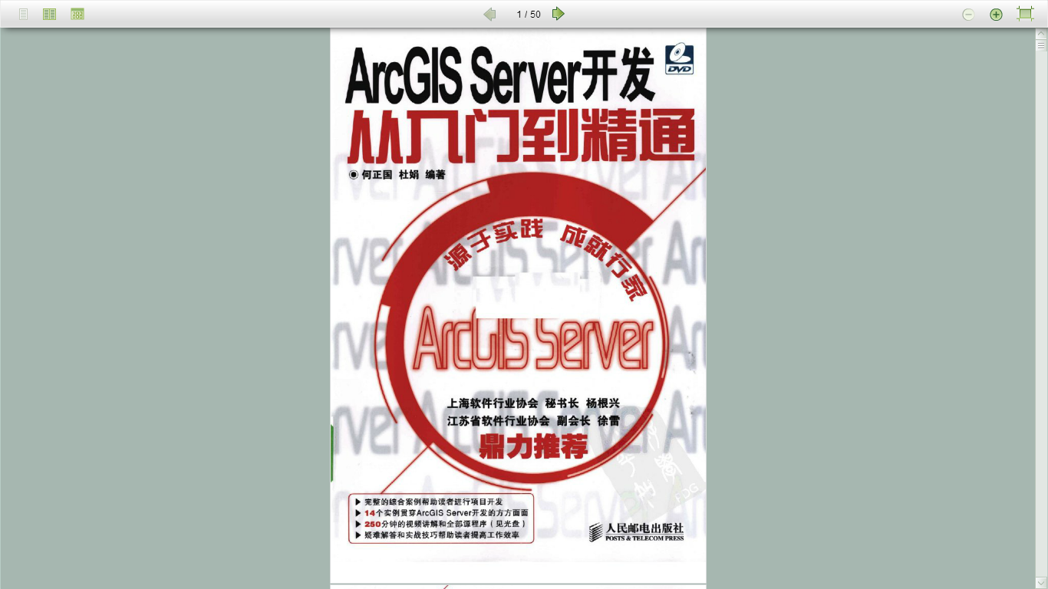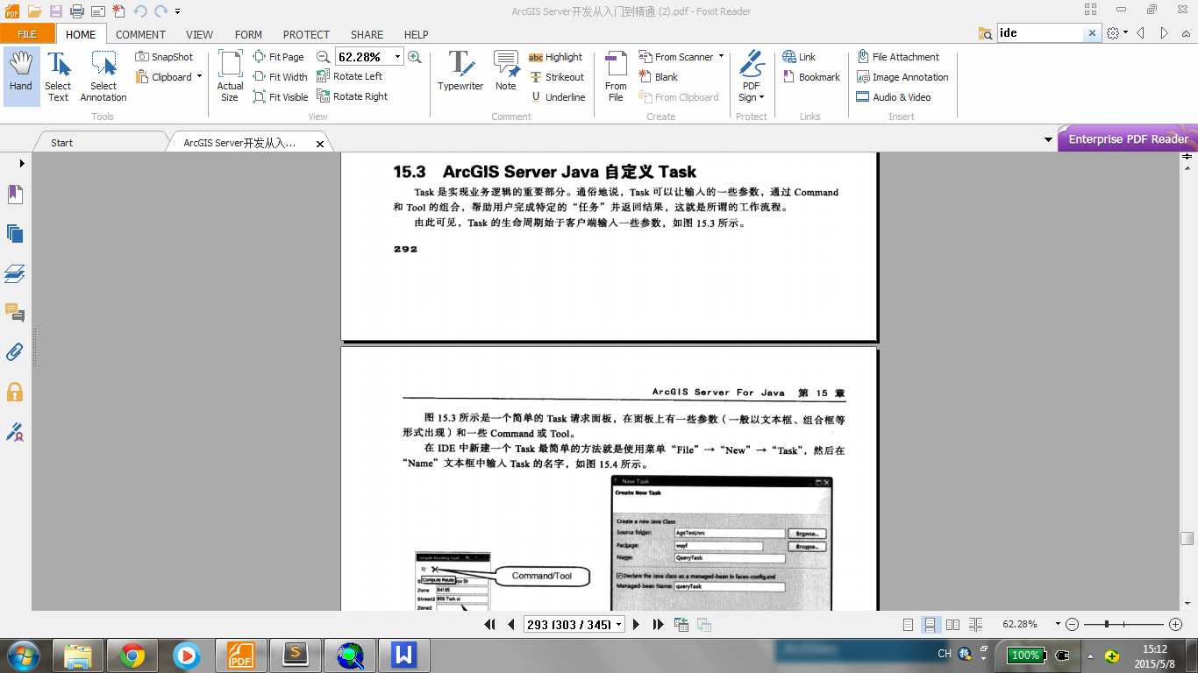

http://help.arcgis.com/en/sdk/10.0/java_ao_adf/conceptualhelp/server/index.html#//0001000003r6000000
How to write a custom task

introduction_to_arcgis_server_development_java_web_adf.pdf
http://proceedings.esri.com/library/userconf/devsummit08/papers/introduction_to_arcgis_server_development_java_web_adf.pdf

MyTask.java

.net版本
.java版本

